https://administrator-webchat.adminml.com/supervisor/index

Login: ext_todale

Senha: Meli@2021 Levitico#7

<div class="select2-container select2-container-multi form-control" id="s2id_selectSkills">

SEARCH call javascript populateAgentsTab()

<button class="btn btn-info" onclick="populateAgentsTab()">

<span class="glyphicon glyphicon-search"></span></button>

<ul class="select2-choices">

<li class="select2-search-choice">

<div>MLB_TopOn_TopOff</div>

<a href="#" class="select2-search-choice-close" tabindex="-1"></a>

</li>

<li class="select2-search-choice">

<div>MLB_TopOff</div>

<a href="#" class="select2-search-choice-close" tabindex="-1"></a>

</li>

<li class="select2-search-field">

<label for="s2id_autogen2" class="select2-offscreen"></label>

<input type="text" autocomplete="off" autocorrect="off" autocapitalize="off" spellcheck="false" class="select2-input" id="s2id_autogen2"

placeholder="" style="width: 34px;" aria-activedescendant="select2-result-label-1382"> </li></ul>

<button class="btn btn-info" onclick="populateSupervisorTab()

= = = = =

<tr class="even" id="agentData_tcorreia" role="row">

<td> <a href="javascript:void(0);" class="glyphicon glyphicon-plus"></a></td>

<td hidden="" class="sorting_2">tcorreia</td>

<td hidden="">tcorreia</td>

<td>Taina Correia</td>

<select name="agentStatus" class="form-control" id="agentStatus" value="online" . . . </select></td>

<td>-</td>

<td>2</td>

<td>15/07/2021 11:59:20</td>

<td hidden="">tcorreia</td>

</tr>

<tr class="even" id="agentData_natlopes" role="row">

<td><a href="javascript:void(0);" class="glyphicon glyphicon-plus"></a> </td>

<td hidden="" class="sorting_2">natlopes</td>

<td hidden="">natlopes</td>

<td>Natalia Lopes</td>

<select name="agentStatus" class="form-control" id="agentStatus" value="online" . . . . . </select></td>

<td>-</td>

<td>3</td>

<td>15/07/2021 08:59:37</td>

<td hidden="">natlopes</td>

</tr>

var **tabla** = driver.FindElement(By.Id("splitWindowList"));

IList<IWebElement> **Rows3** = tabla.FindElements(By.ClassName("first"));

IList<IWebElement> Cells = driver.FindElements(By.TagName("td"));

IList<IWebElement> plusSigns = driver.FindElements(By.ClassName("glyphicon glyphicon-plus"));

IList<IWebElement> Statuses = driver.FindElements(By.ClassName("agentStatus"));

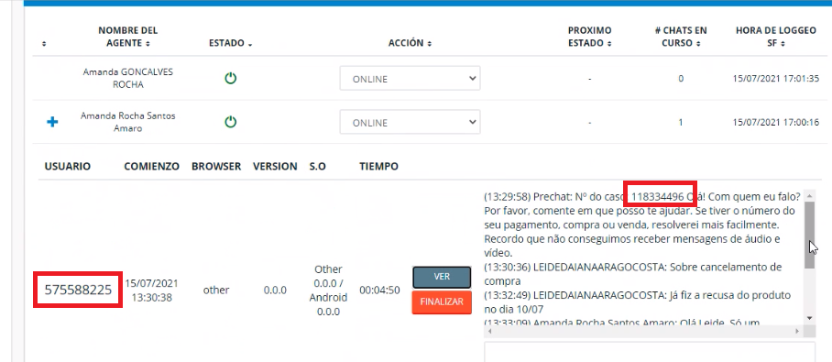

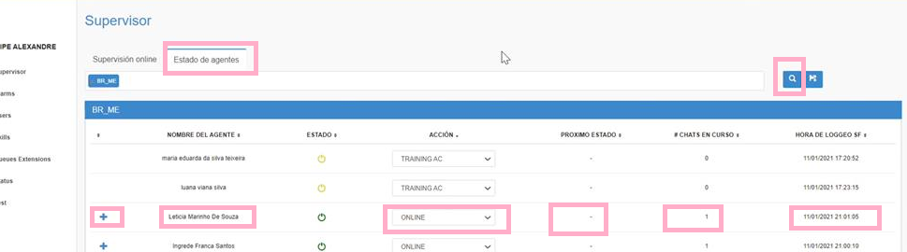

<tr class=even id=agentData_tcorreia" role=row>

<td> <a href= class=glyphicon glyphicon-plus></a>

<td class="sorting_2">tcorreia

<td >tcorreia

<td>Taina Correia

<STATUS=online . . . </select>

<td>2

<td>15/07/2021 11:59:20

<td >tcorreia

</tr>

<tr class="even" id="agentData_natlopes" role="row">

<td><a href="javascript:void(0);" class="glyphicon glyphicon-plus"></a>

<td "" class="sorting_2">natlopes

<td "">natlopes

<td>Natalia Lopes

<select name="agentStatus" class="form-control" id="agentStatus" value="online" . . . . . </select></td>

<td>-</td>

<td>3</td>

<td>15/07/2021 08:59:37</td>

<td hidden="">natlopes</td>

</tr>

<tr agentData_tcorreia

<td>

<td >tcorreia

<td >tcorreia

<td>Taina Correia

<STATUS=online . . . </select>

<td>2

<td>15/07/2021 11:59:20

<td >tcorreia

</tr>